Hibernate

Object relational impedance mismatch

1)granularity

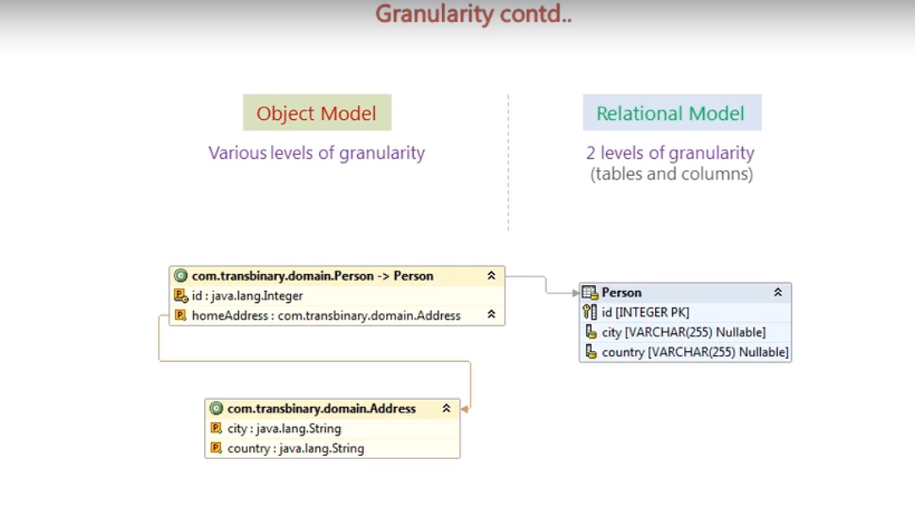

2 Inheritance

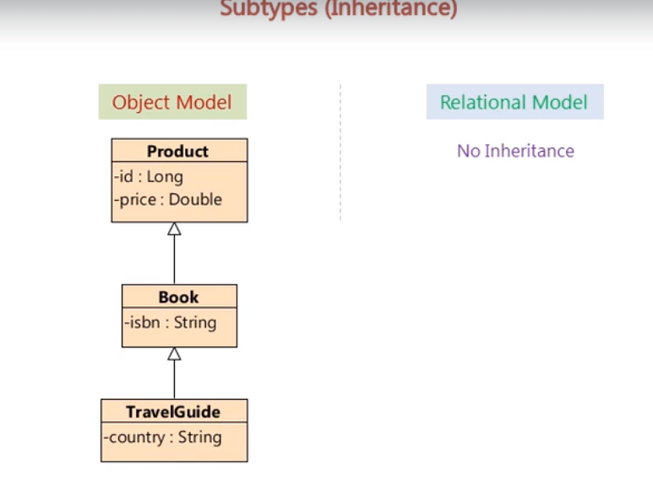

3.Identity

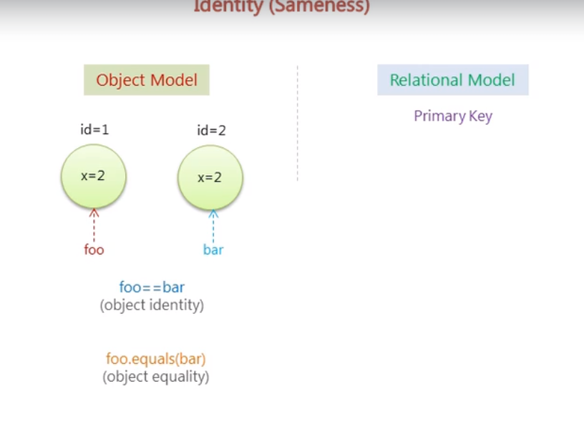

4 Associations

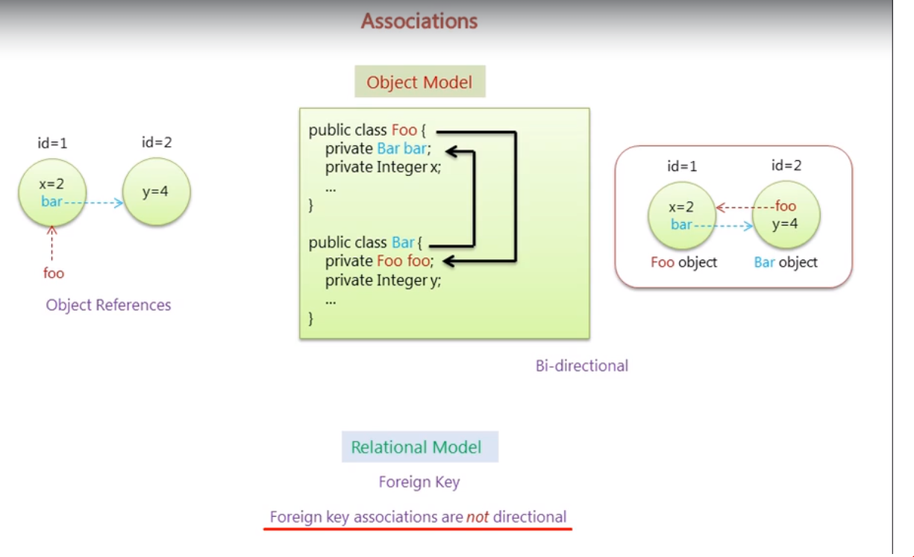

5. Data Navigation

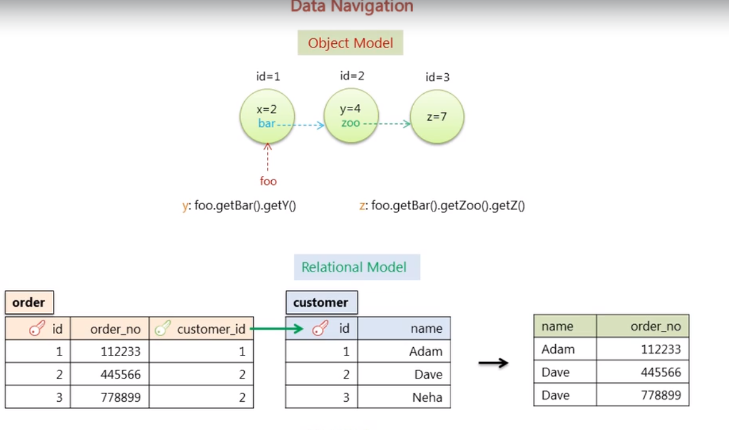

(usage of join vs sub query )

JDBC pitfalls

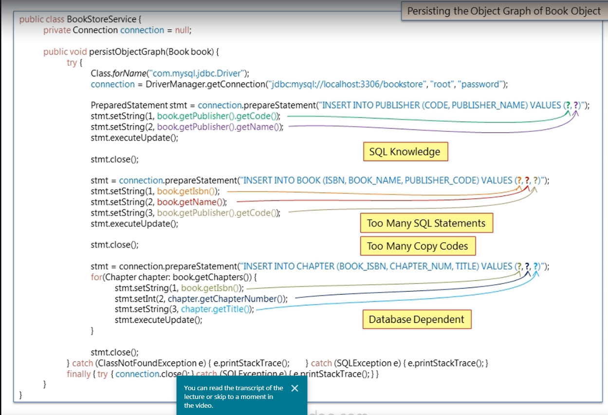

Hibernate

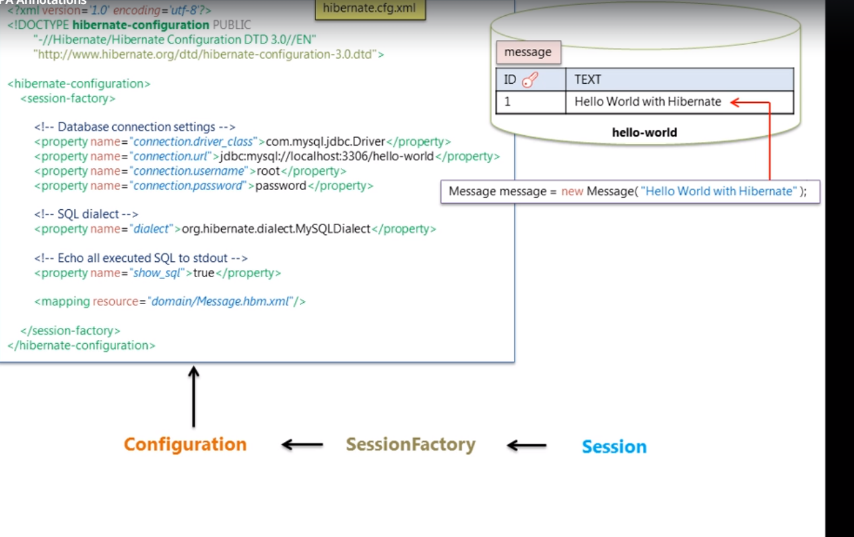

Log4j for hibernate logs

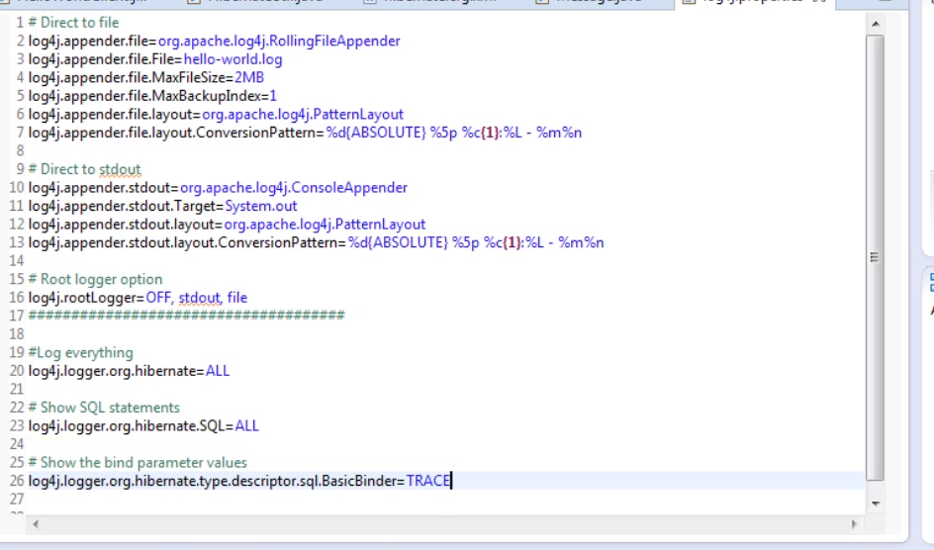

Auto matic dirty checking

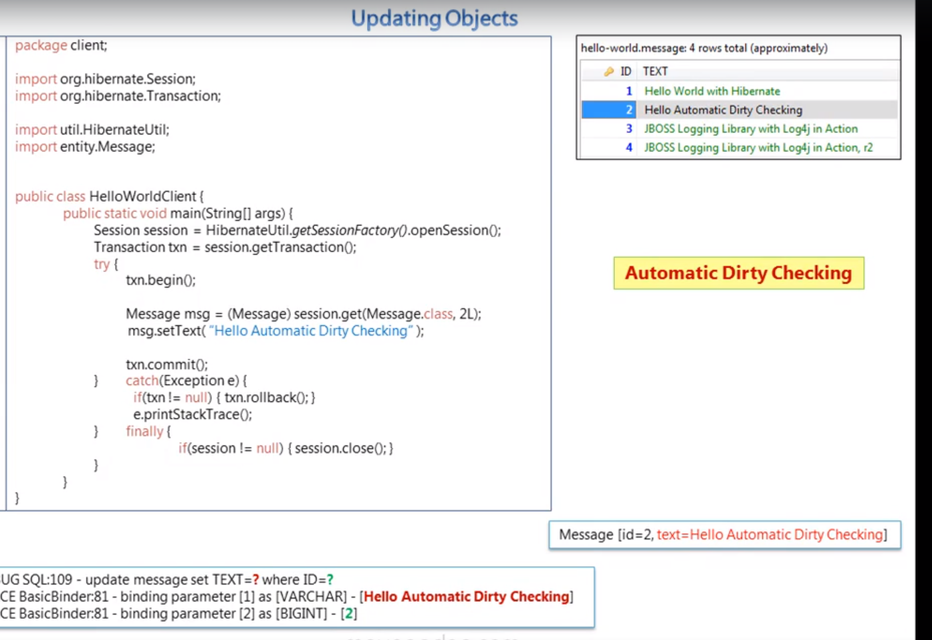

To remember

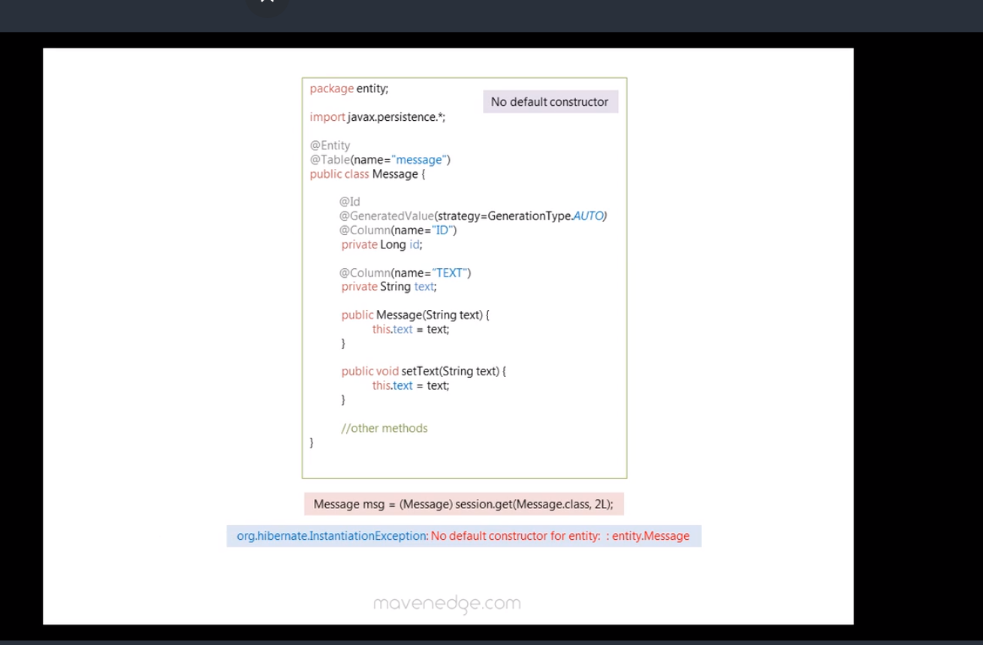

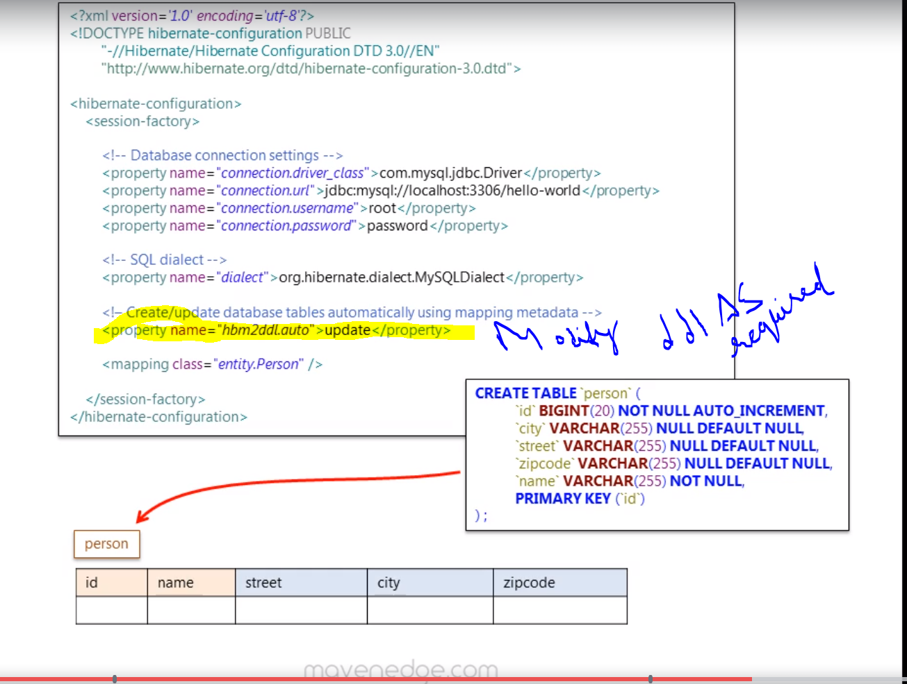

Attribute override

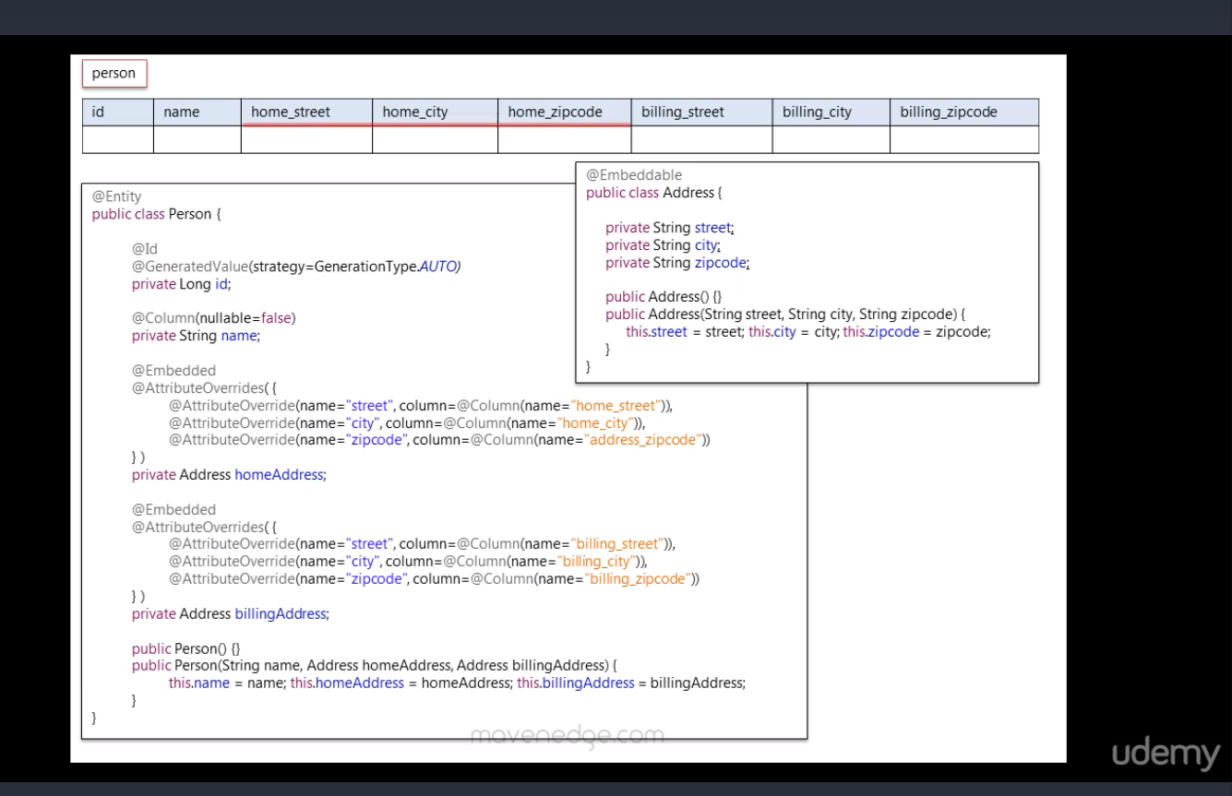

Cascading persist

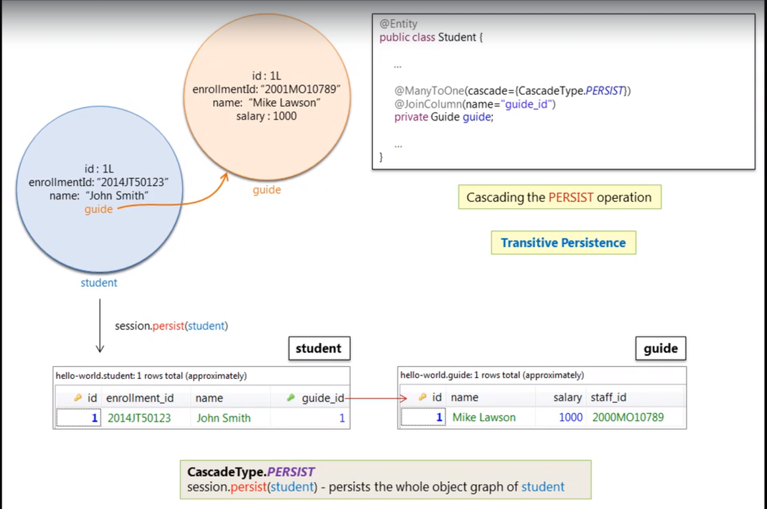

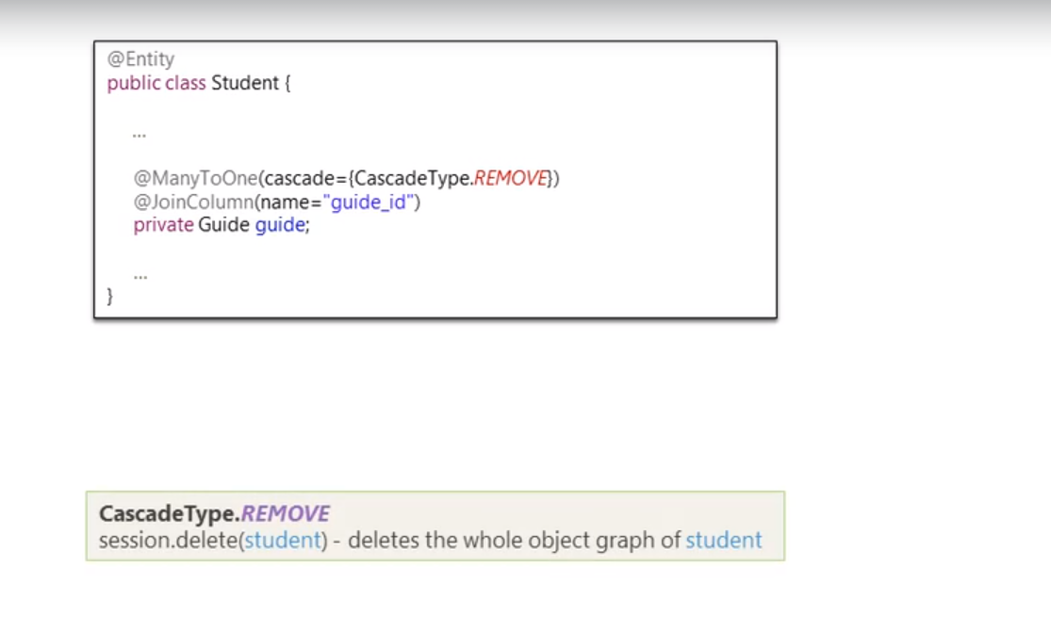

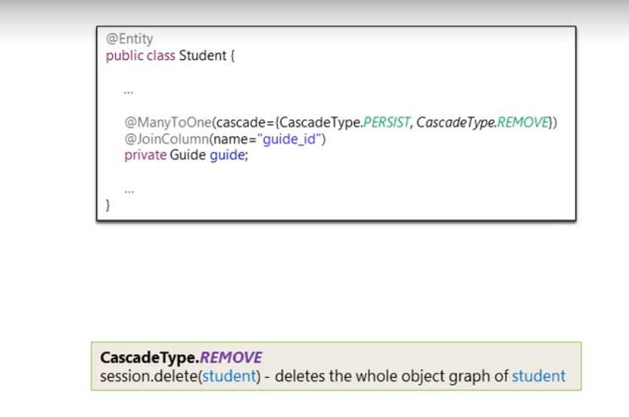

Bidirectional Mapping

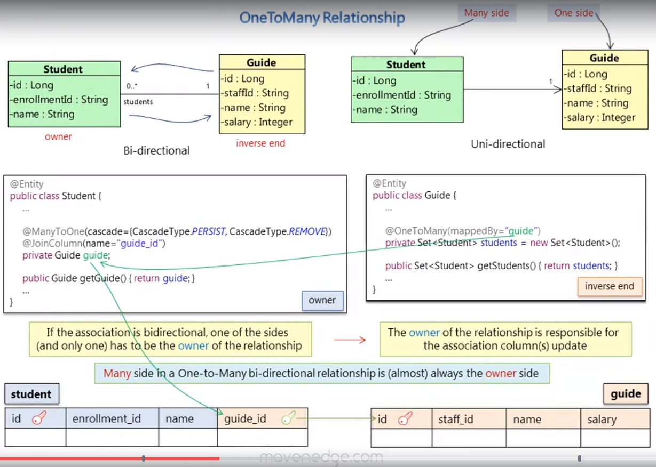

One to one

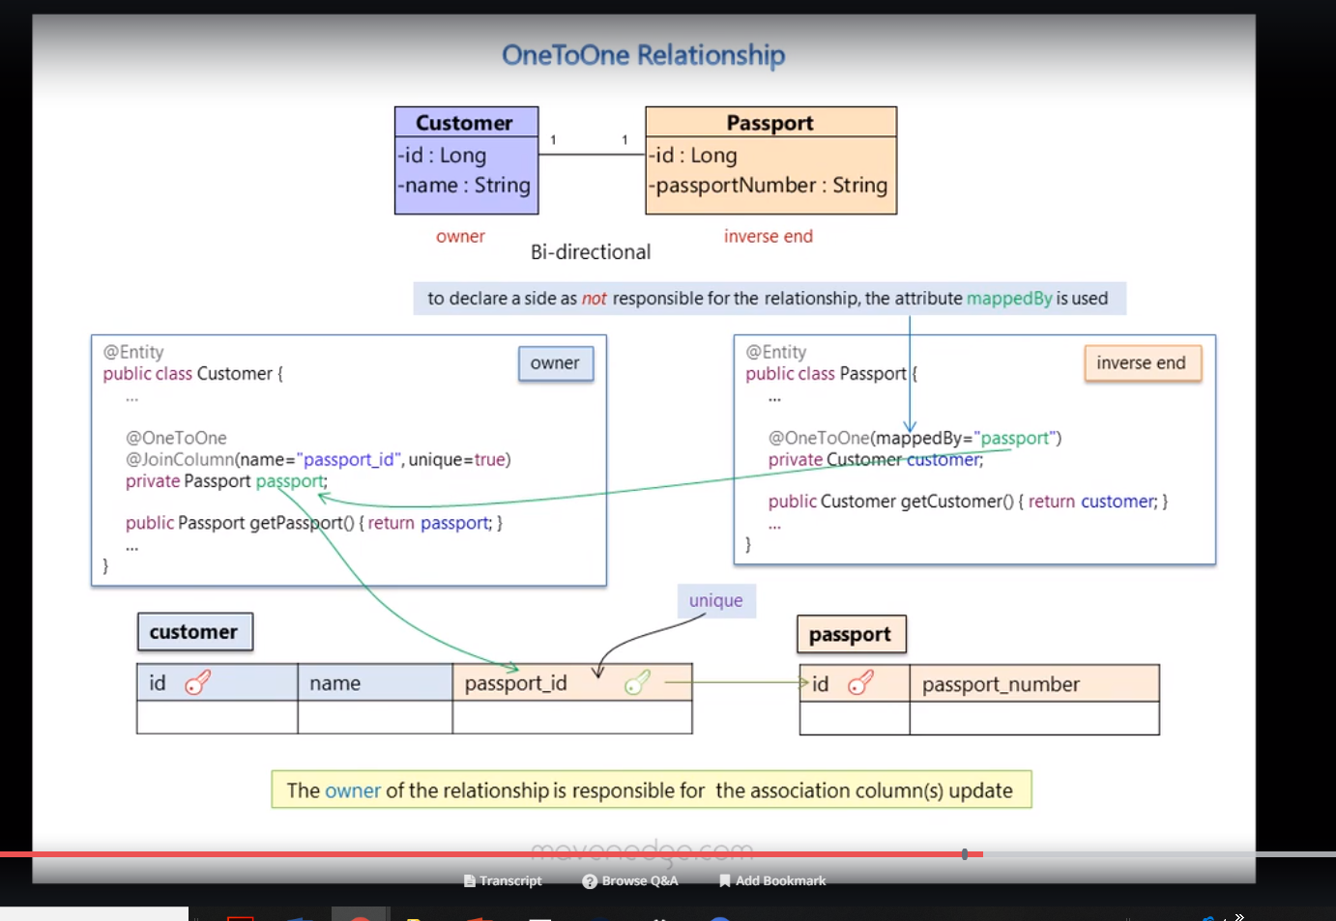

Enums

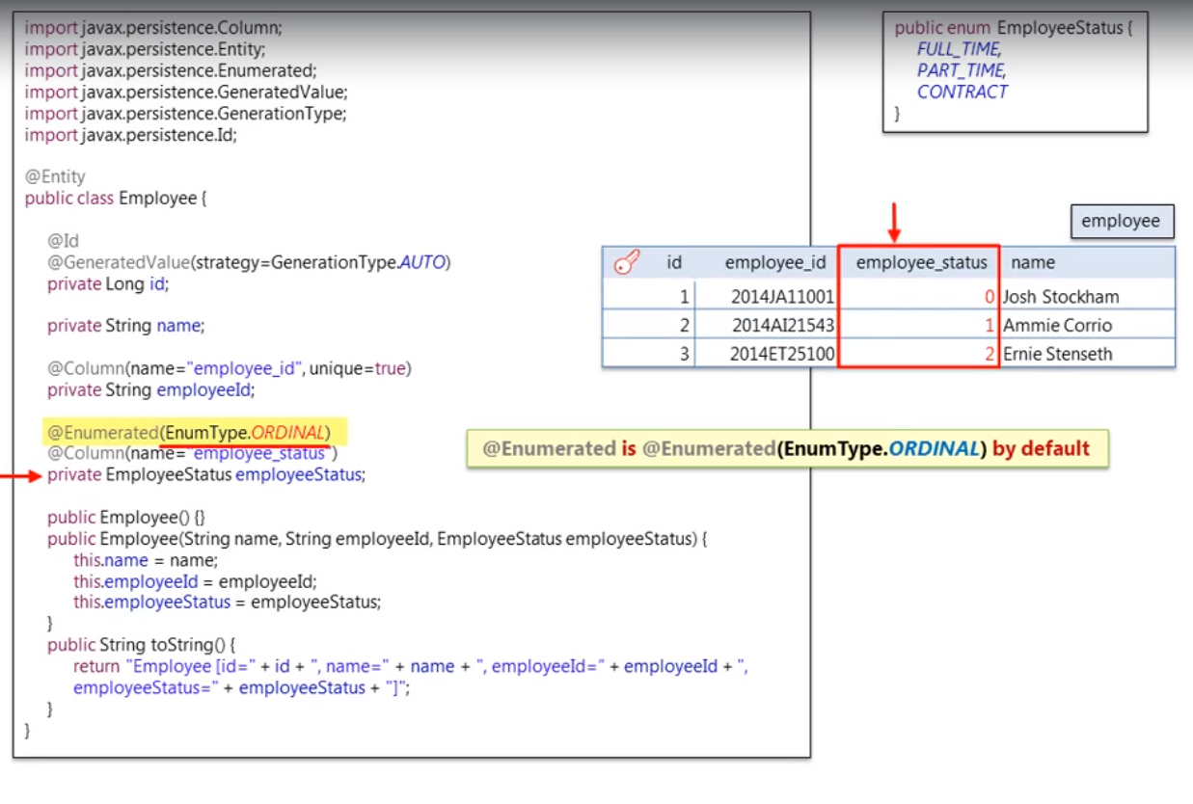

Mapping Collection s

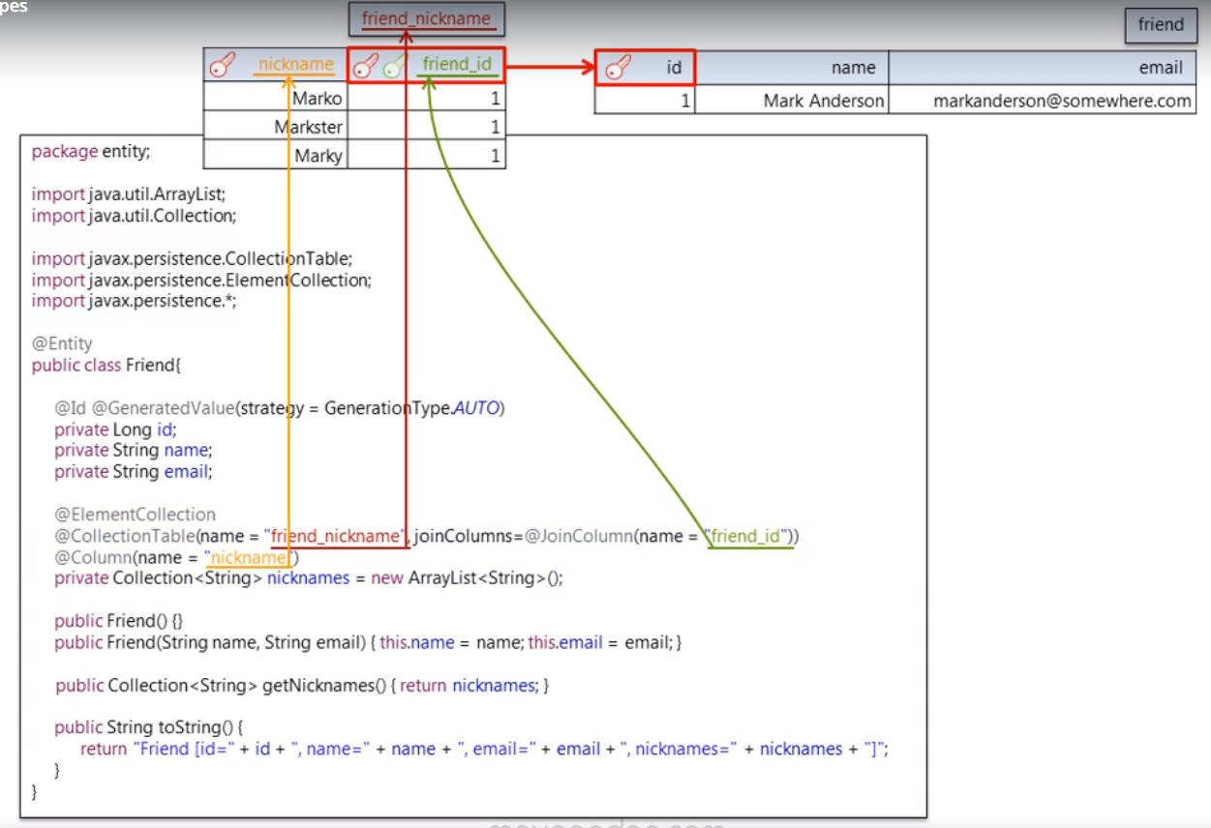

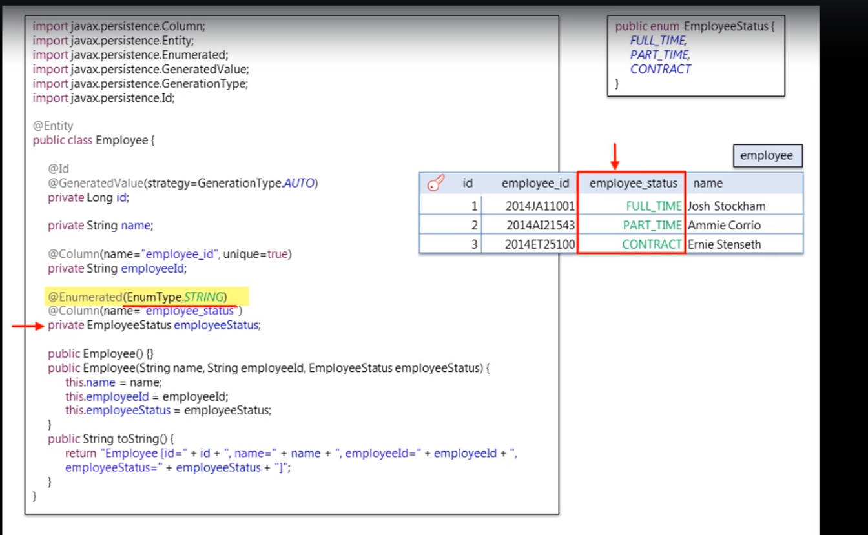

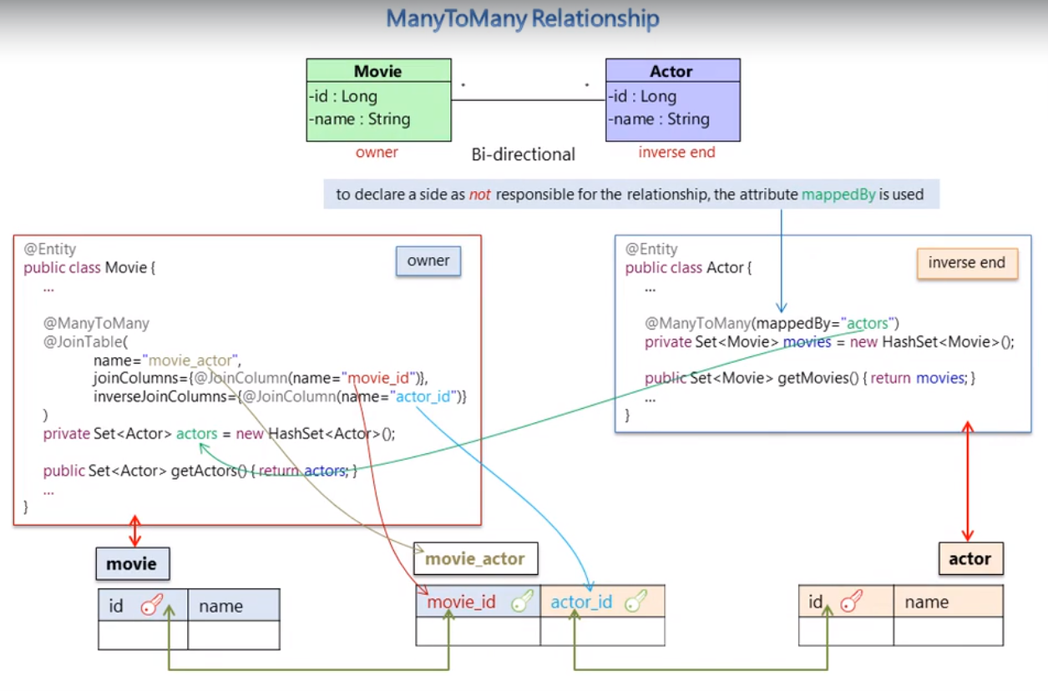

Collection of non element values

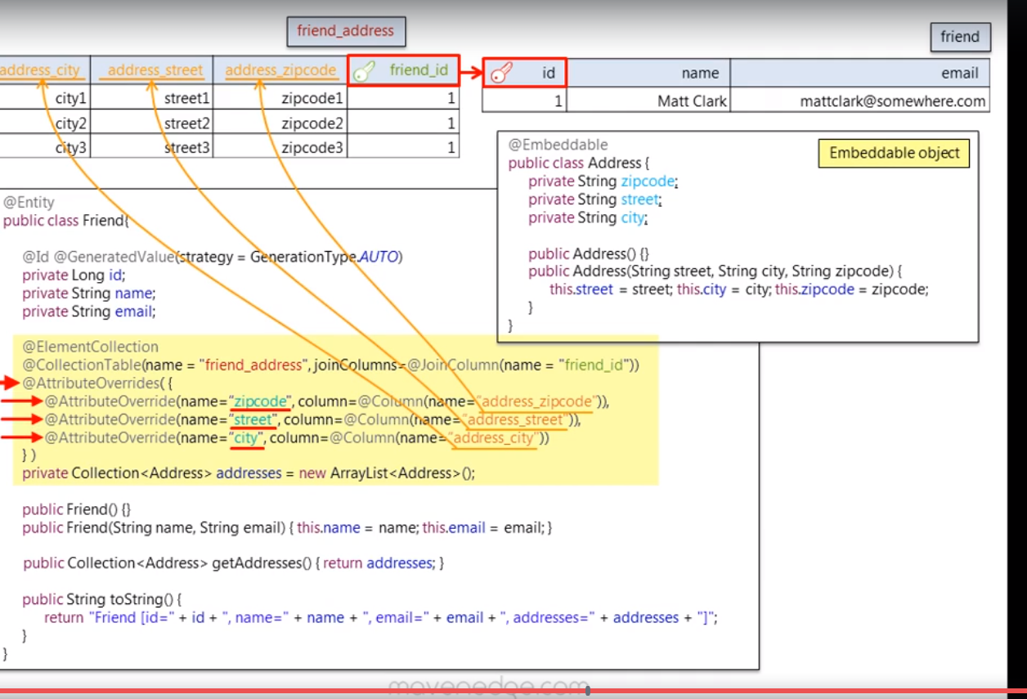

Composite keys

Composite primary

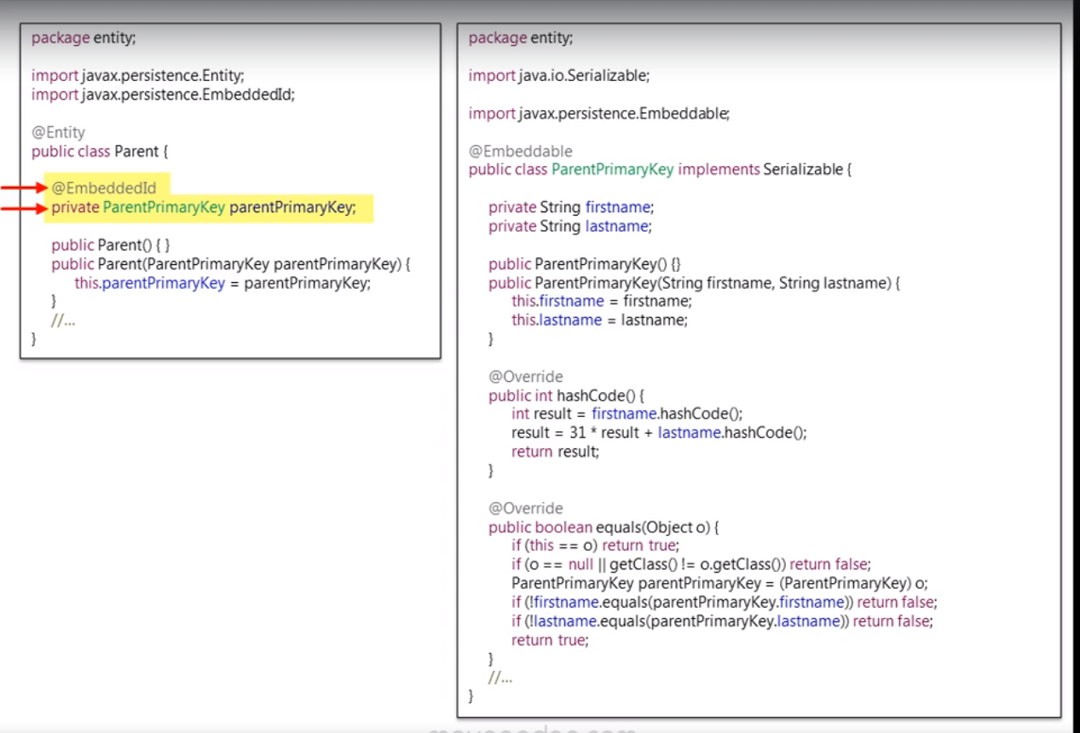

Composite foreign keys

JPA  
JPA is specification for persitance, there are numerous providers for JPA including Hibernate ,eclipse link ,I,e they implement the JPA interface.

Mapping between jpa and hibernate

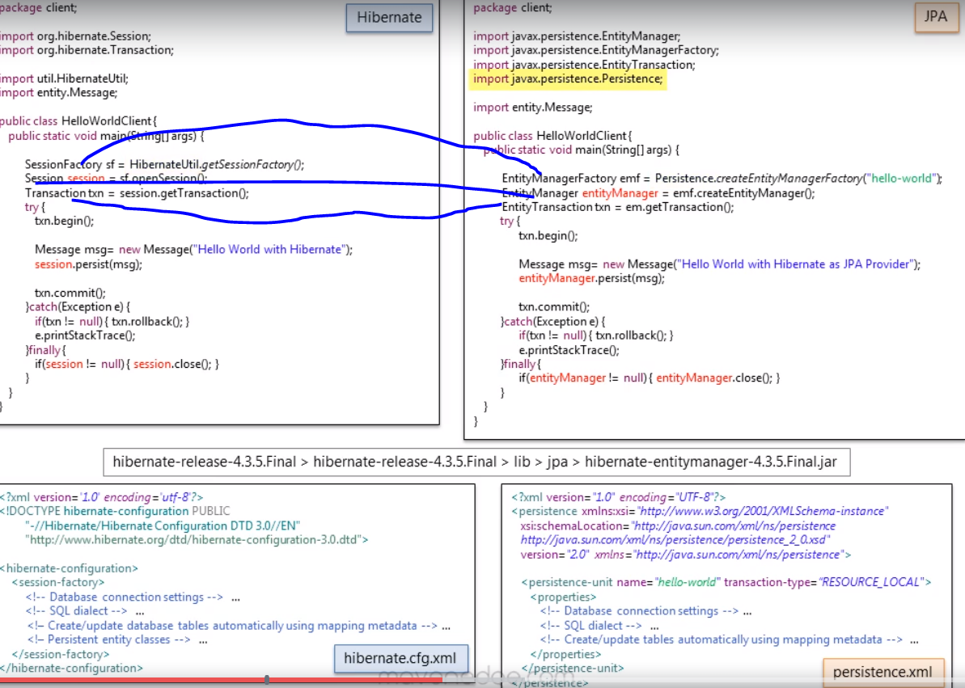

Configuring Entity Manager

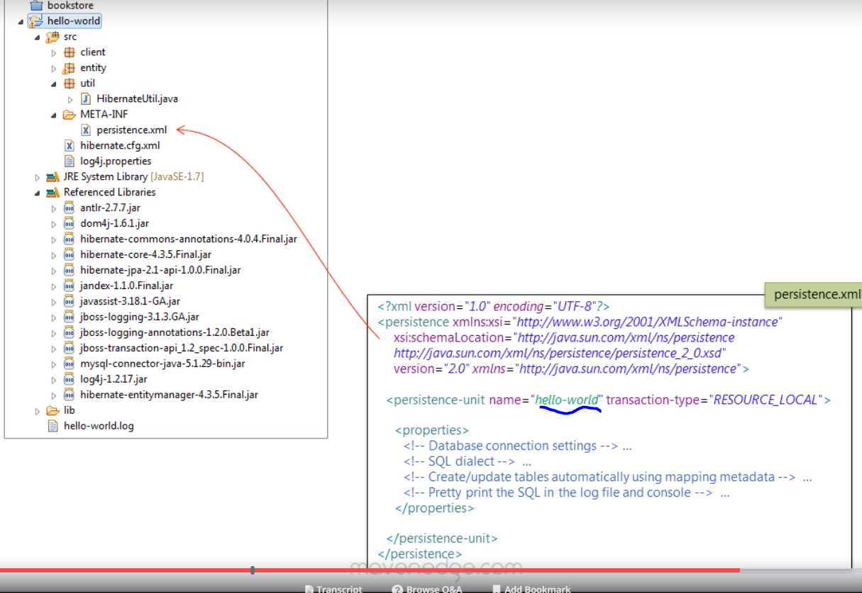

Example persistence.xml

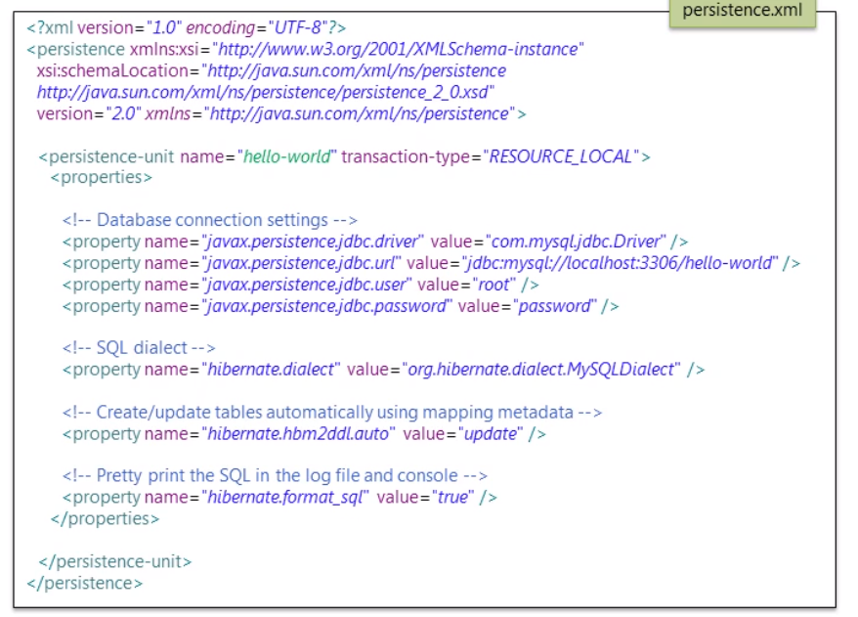

If entity manger factory is not responsible for creating the entity manager then use eg glassfish

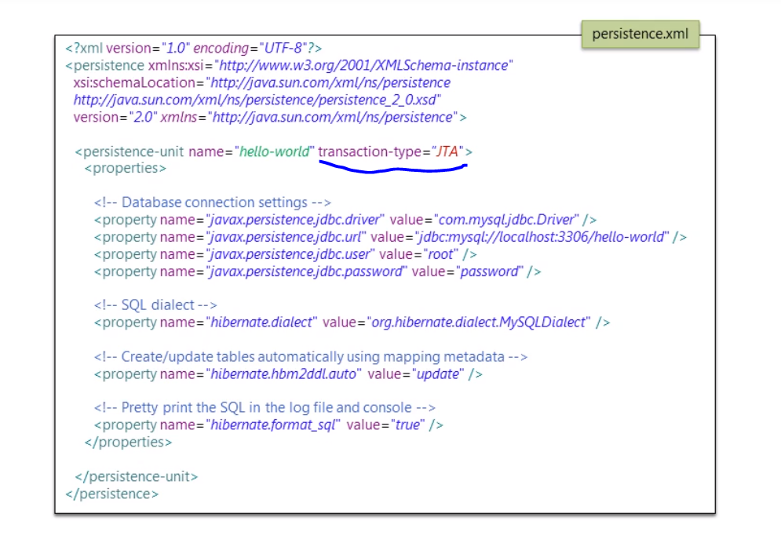

Object States

Persistant -> managed both by JVM and entity manager within a transaction .

Transient -> Object that lives in JVM memory and managed only by JVM .

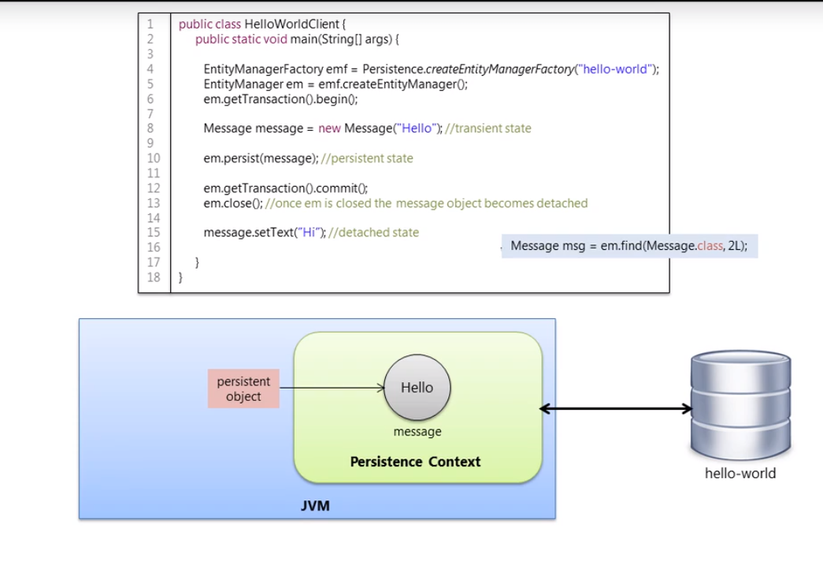

Notes :

Persistant object is always associated with a persistence context .A persistence context (first level cache ) has its own non shared database connection and is responsible for **dirty checks.**

Dirty check means to check the state of the object for modification within a transaction .It also updates those changes to transaction when the transaction is committed .

**Cache**

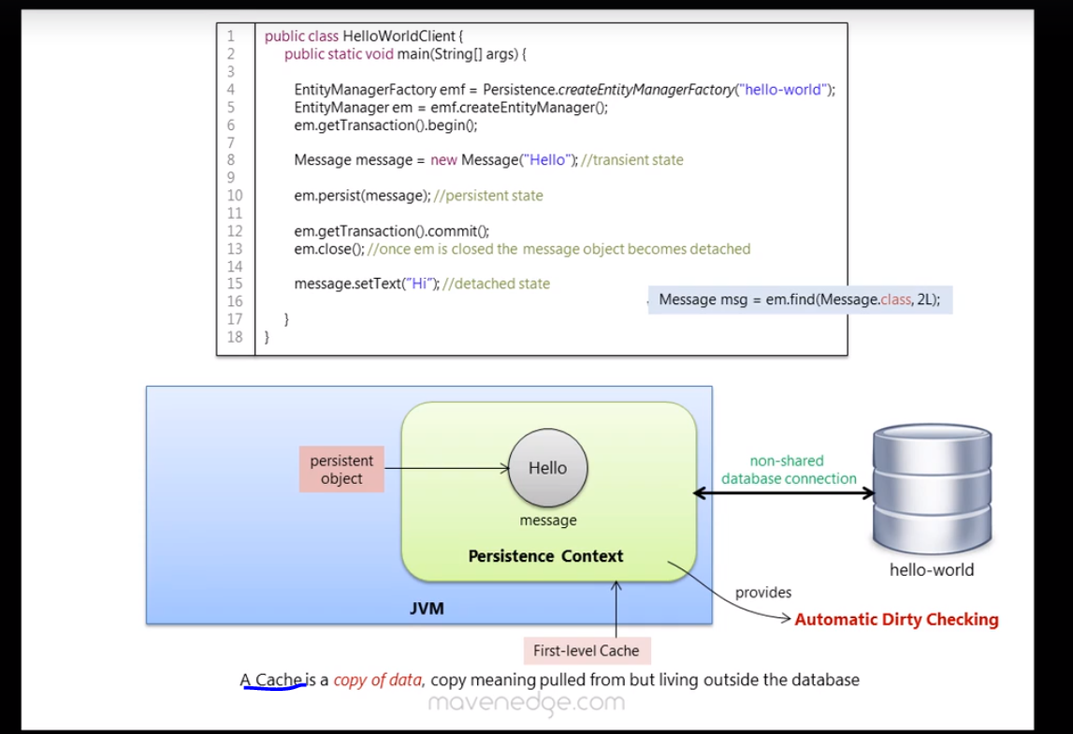

Persistance Context

When an JPA entityManager/Hibernate Session is created corresponding persistence context /internal persistence context is created along with it .

Persistance object going to a detached State

Way 1

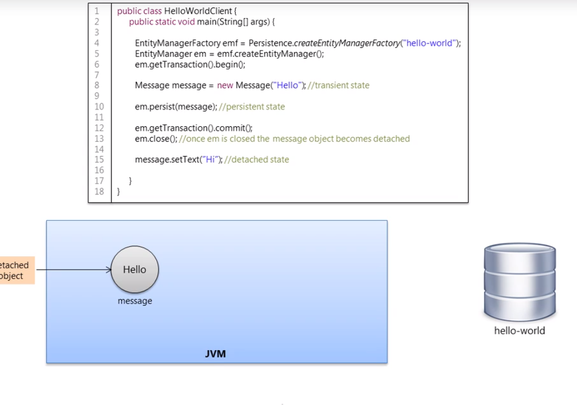

Way 2

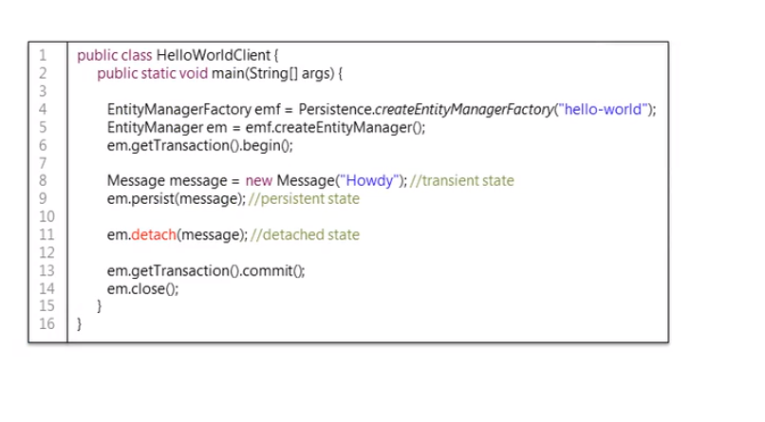

Steps to attach a detached object

Use a merge methord with the reference of the detached object .

**Behind the scene operations when using a different entity manager**

1.from the persistant context (local cache) find any object with the same @id

2.If none is found load one from the db into the pesistance context .

3. copy the state of the referenced object in the merge methord on to the peristance context.

4.commit the loaded object .since the object is dirty changes are persisted

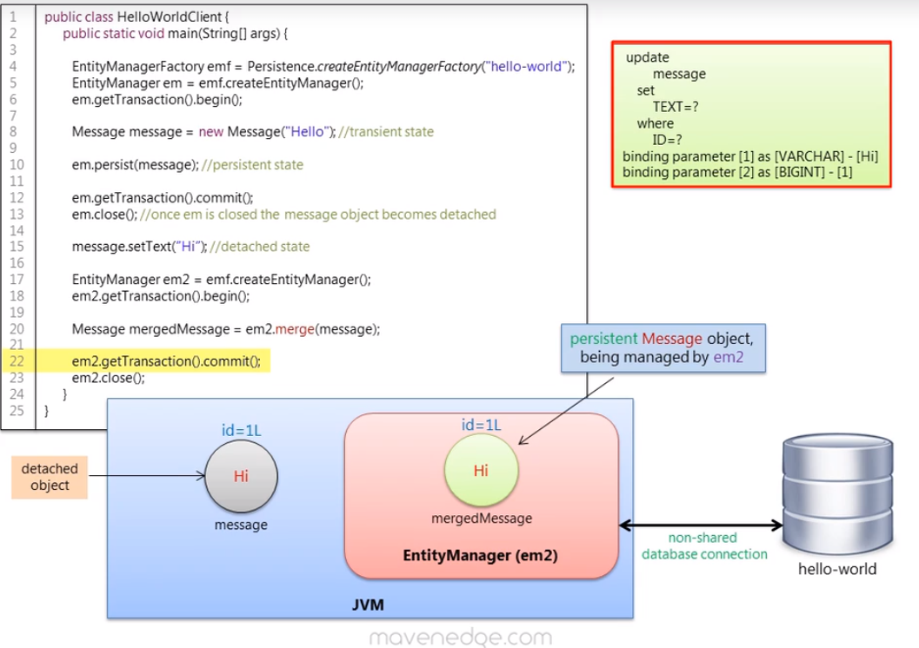

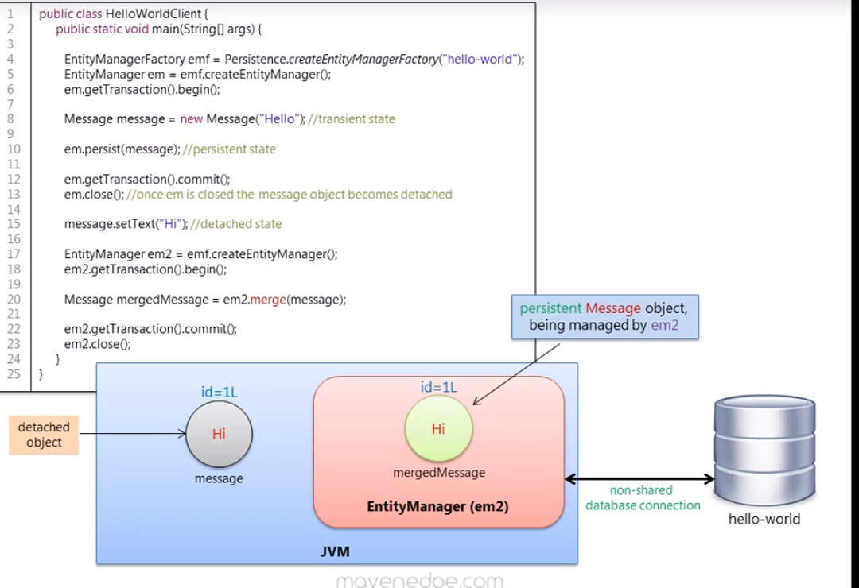

First and second level cache

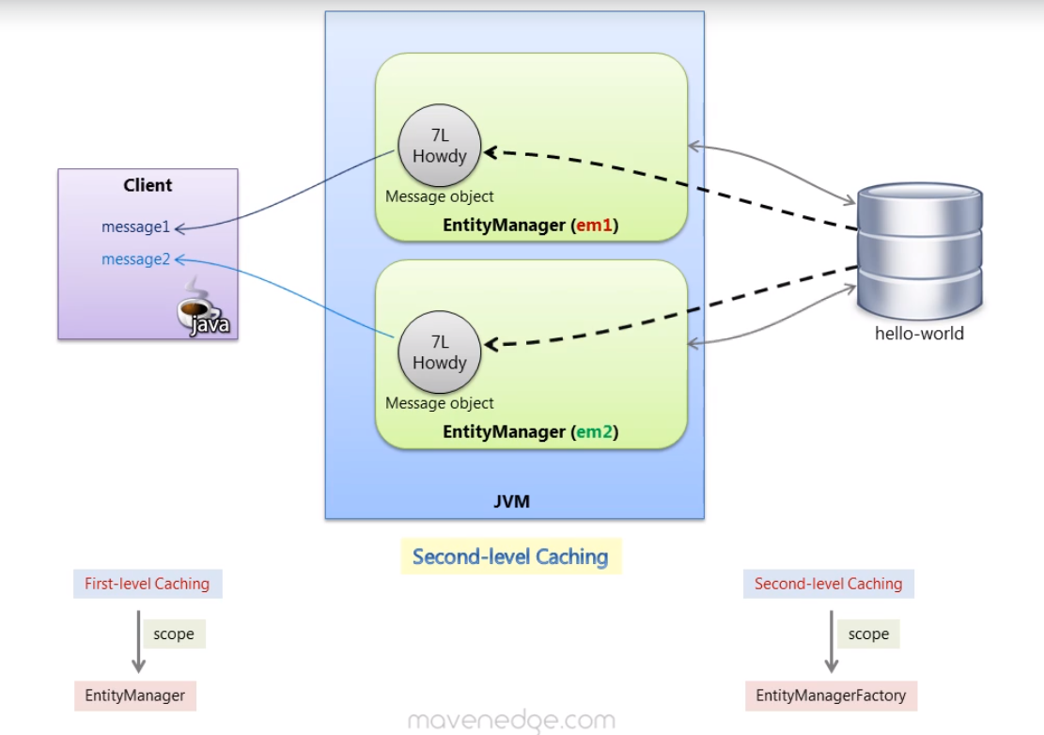

Joins ,

Inner Join

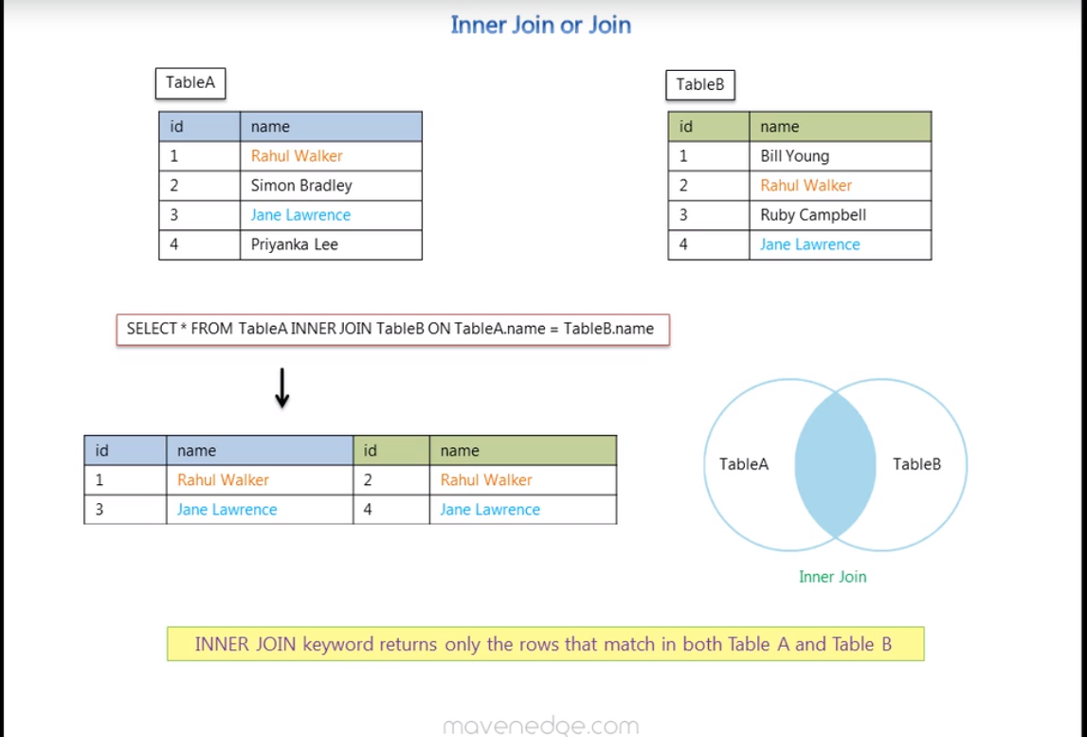

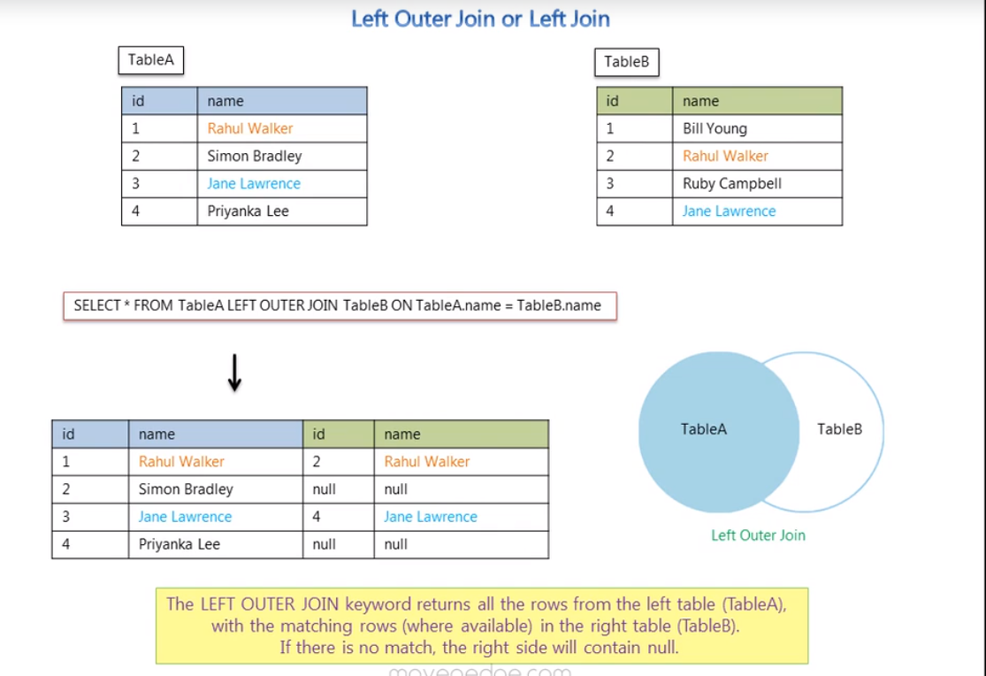

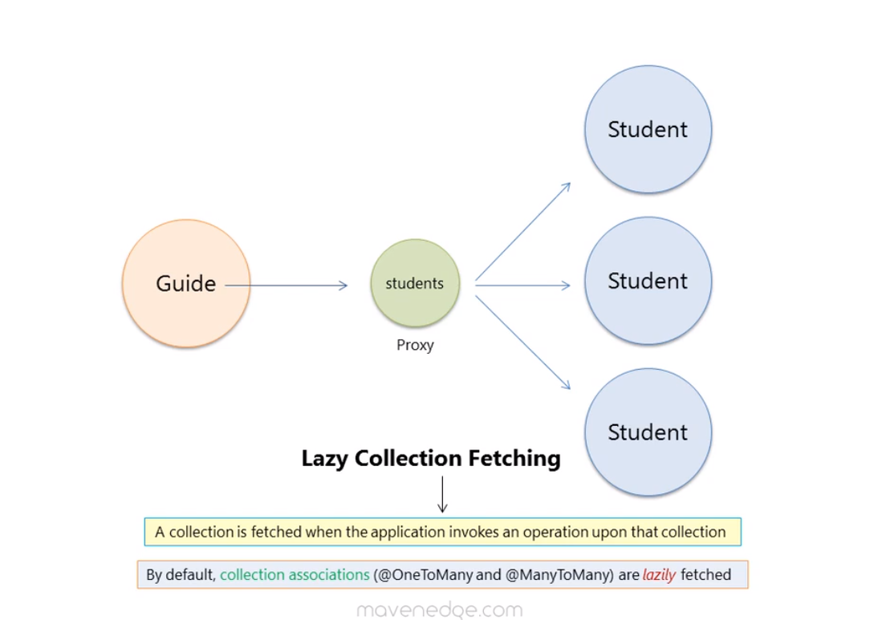

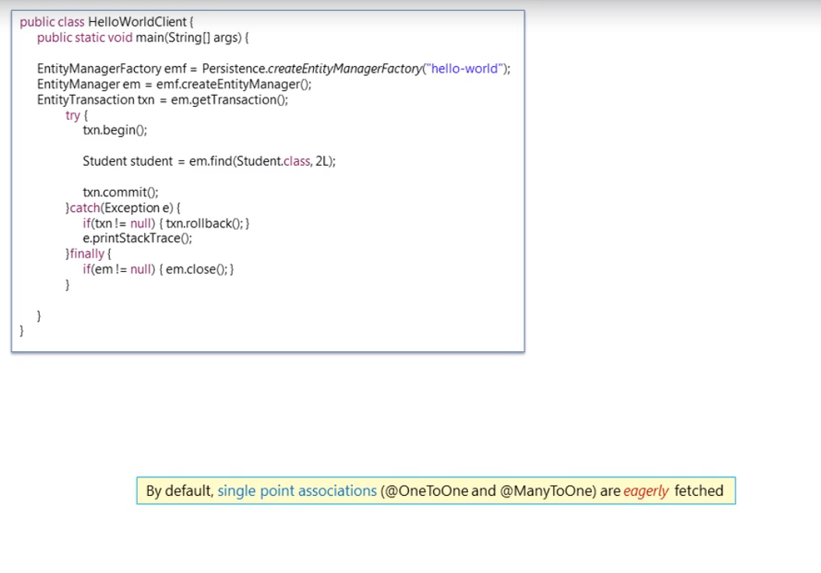

Lazy initialization exception

|  |  |
| --- | --- |
| Association type | Default fetch type |
|  |  |
| one to one | Eager |
| many to one | Eager |
| one to many | Lazy |
| manyto many | Lazy |

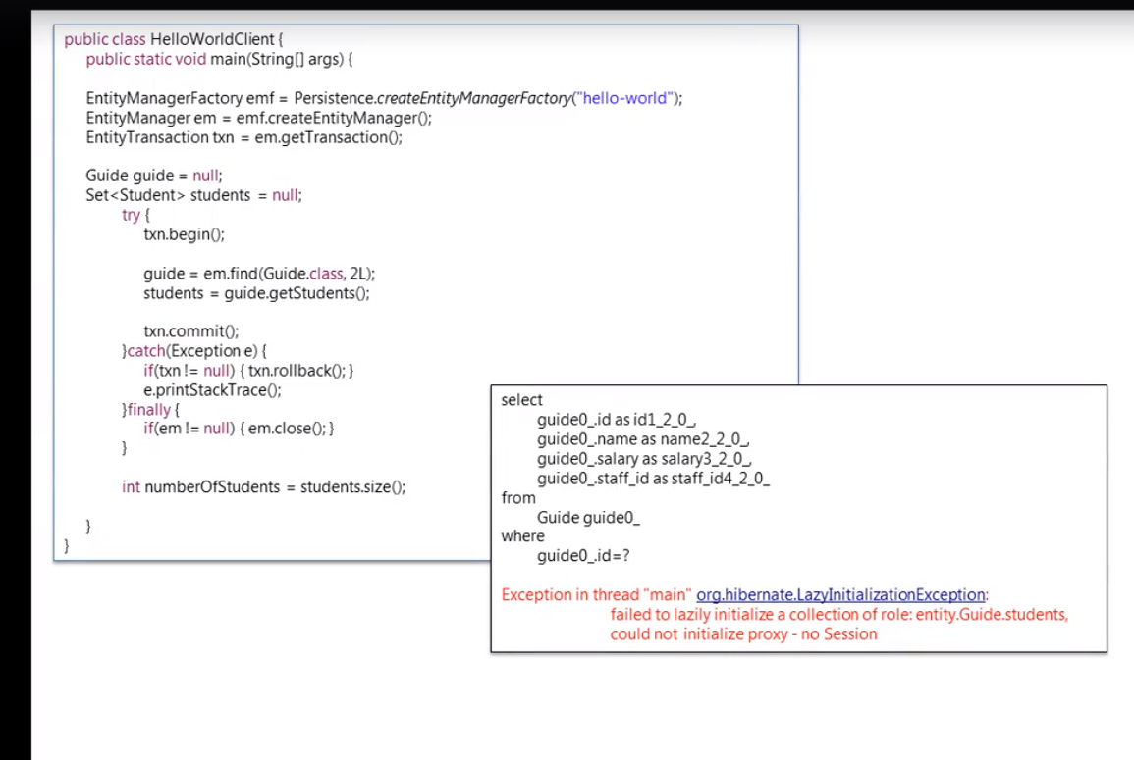

Equals and hash Code

Equals methord compares 2 objects by comparing their address in java memory.

How ever a collection (hashset) the operation like contains will check for hashcode before checking for equals

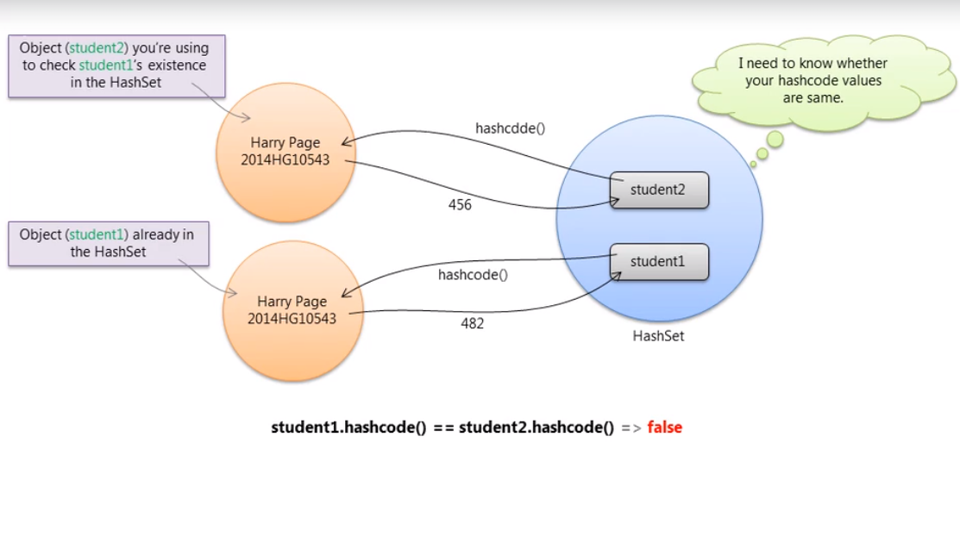

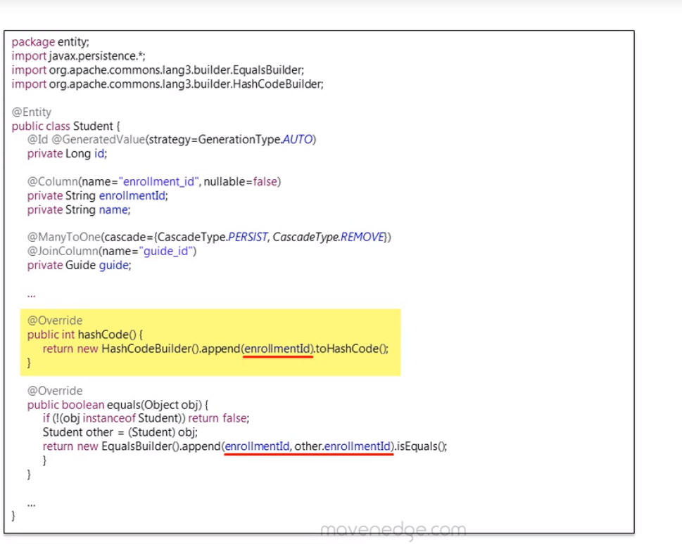

Working with hibernate equals and hash code

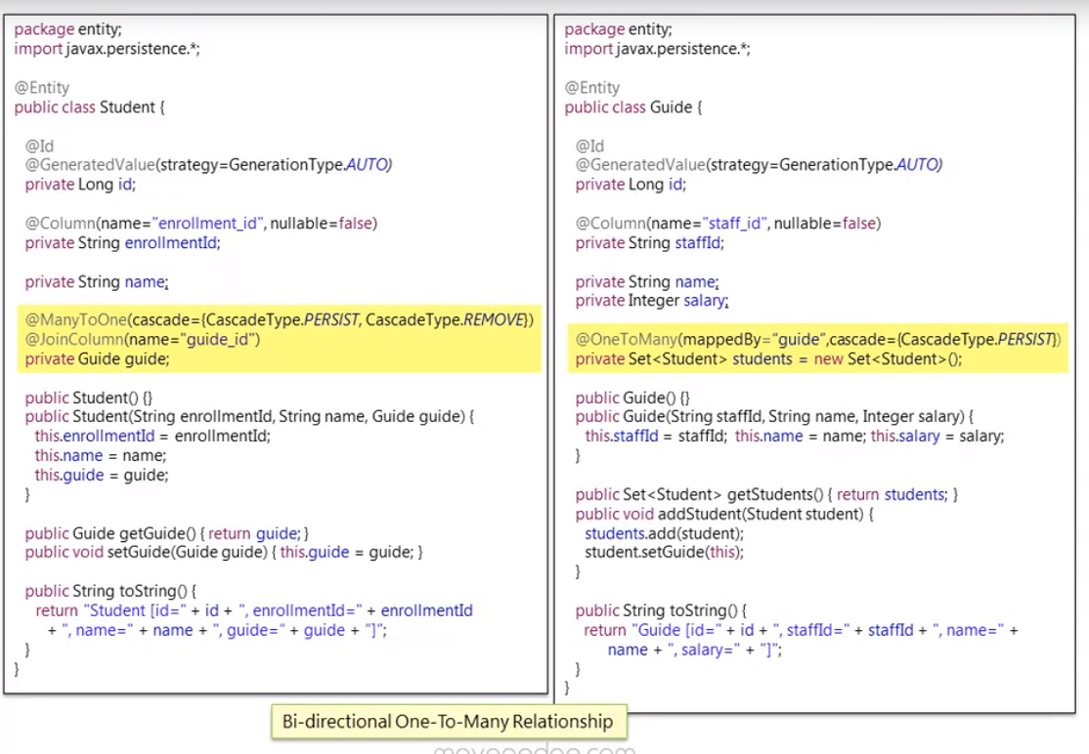

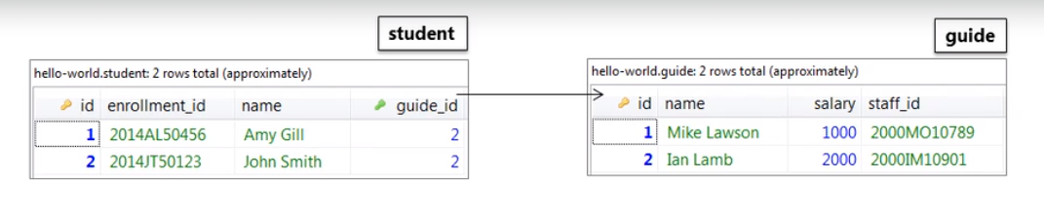 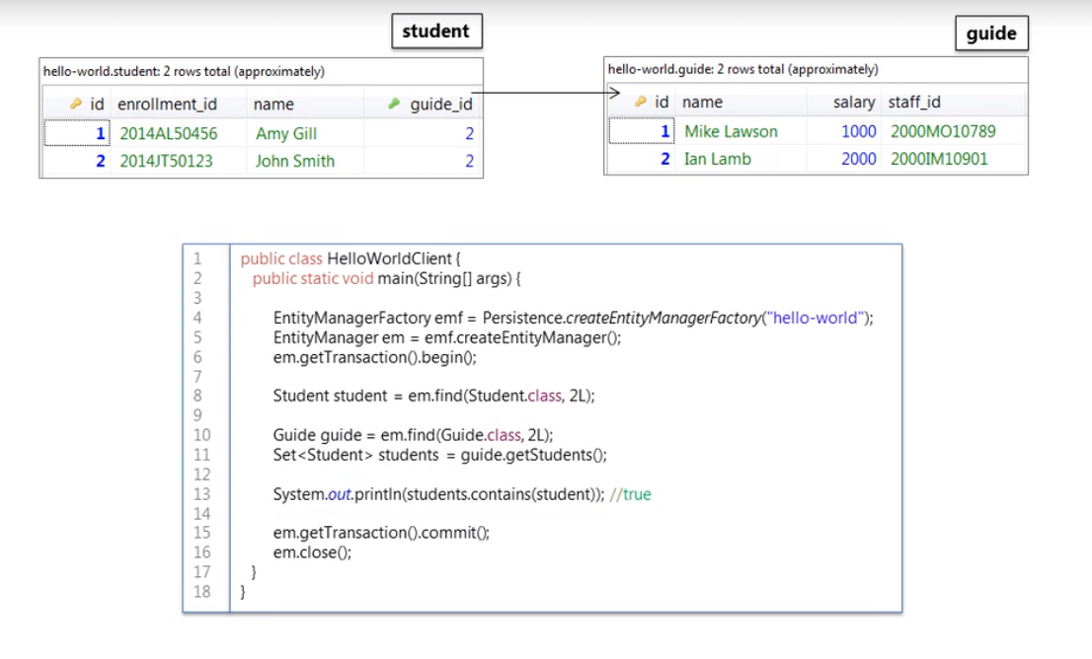

Question line num 13 should be false because we have not implemented the hash code methord in the student class hence we assume it to be ture however ,its false because of the following .

Once line 8 is executed the guide object is Eager fetched .how ever the student collection in guide object is proxied coz (lazy fetched -> one to many )

.all of these objects are present in the persistant context .

once line 11 is executed the proxy is fetched from db but since student 2 is available in persistent context it will fetch only student 1 from db .

this is the reason we get true as o/p for line 13.

But as a good practice we have to implement equals and hash code for entities aged to a set with their business keys (ssn, student id ).

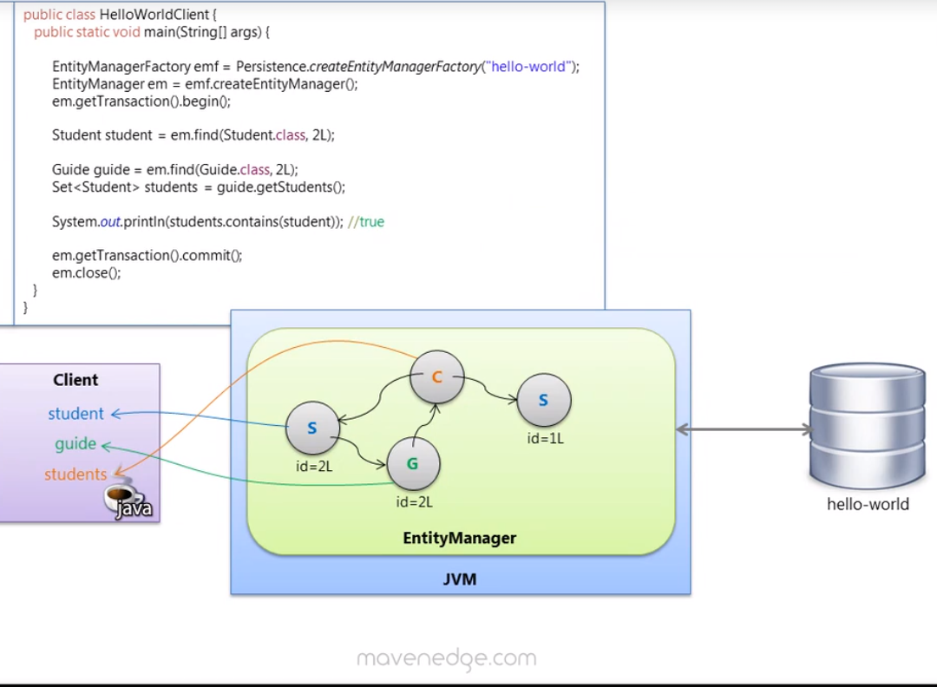

Note if the line10 11 and 13 were done outside an entity manager the output would have been false

